Shabbos Stories For
Yom kippur 5788
Volume 19, Issue 1 1-2 Tishrei/October 2-3, 2027
Printed L’illuy nishmas Nechama bas R’ Noach, a”h
For a free email subscription, send your request to keren18@juno.com

Zaidy’s Yom Kippur
By Devora Leah Riesenberg

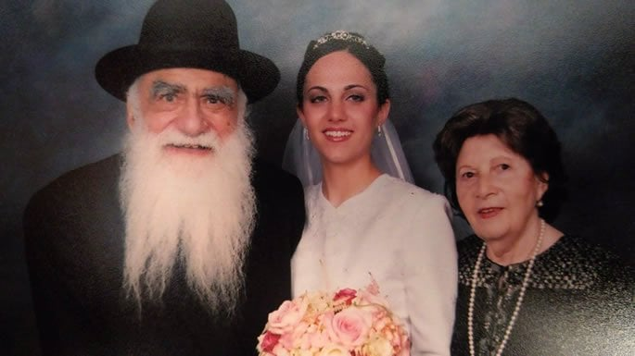
The author with her grandparents.

I stand in shul, shifting my weight from one foot to the other, trying to ignore the groans of my unhappy stomach. I flip through the machzor to see how many pages remain until the end of the service. My mind begins to wander; I am transported back to another Yom Kippur, years ago.
In my daydream I am a child again, and my grandparents have come to spend the High Holidays with my family. My grandfather is in his early seventies, although with his long white beard and bushy black eyebrows, to me he looks at least a hundred years old.
That Yom Kippur I tried hard to stay in shul instead of running outside to play with my friends. I sit in my seat listening intently and trying to follow along. Suddenly, my ears perk up to the sound of a familiar voice ringing out—it is an old voice, but powerful and steady. It is my zaidy (grandfather); he is saying the mourner’s kaddish for his father, whose yahrtzeit (date of passing) is on Yom Kippur.
My thoughts shift to another Yom Kippur in Communist Russia. Rabbi Aryeh Leib Kaplan has just arranged a minyan in a private house in Ch’ili, after being exiled there for the illegal activities of spreading Jewish teaching and observance in his hometown of Kiev. The ever-watchful KGB, infuriated at Aryeh Leib’s persistence in his “crimes” even in his place of exile, send a goon squad to beat him up on his way home from the clandestine Yom Kippur prayer group. Aryeh Leib’s friend is beaten to unconsciousness, and Aryeh Leib just manages to drag himself to the nearest Jewish family to tell them about his injured friend before he collapses and dies. He leaves a young widow and four orphans. One of them is Zaidy.
It is an old voice, but powerful and steady…
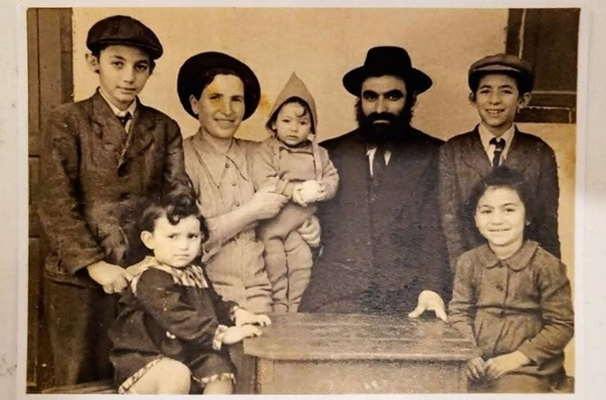
The author's grandfather with his young family.
Yet another Yom Kippur flashes through my mind. There’s a picture of Zaidy, but he’s young and strong. He is surrounded by ruthless criminals in a dingy prison cell, locked up like his father for the heinous crime of practicing Judaism in Communist Russia. In prison, each inmate receives one piece of daily bread. Zaidy knows that he must save that bread for after the fast, or he will die of starvation. However, if the bread isn’t stuffed into his mouth the moment it is handed to him, it will be grabbed by one of many greedy hands. Zaidy approaches “The Chief” of the cell—a hardened criminal whom all of the other inmates fear and respect. Zaidy presents his dilemma, and miraculously The Chief decides to help. The Chief puts the bread on a high ledge, and warns the inmates that he’ll kill anyone who touches it. Many hungry eyes stare at the bread, but no one touches it.
Later, Zaidy needs to know when the fast is over, but there is only one small window high up on the wall of the cell, and there is no way to tell the time. Zaidy approaches The Chief again and explains his dilemma: he needs to know when it is completely dark in order to break his fast. The Chief gives orders, and a human pyramid is formed—one criminal on the shoulders of another, until they reach the window. The inmates repeat this pyramid every couple of minutes, reporting on what they see, until Zaidy confirms that the fast is over.
The voice of the cantor breaks through my reverie and brings me back to my open machzor. As I resume my prayer, I once more think of Zaidy and my great-grandfather. I feel them smiling down on me.
Zaidy, Rabbi Moshe Binyamin Kaplan, escaped the Soviet Union with his young family, whom he raised in the United States. He passed away in 2005. The story of his Yom Kippur in prison is just one of many of his heroic acts in order to keep Judaism in Communist Russia.

Reprinted from the Yom Kippur website of ChabadOrg.

Teaching the Alef Beis
By Rabbi Moshe Hirch

After Rabbi Shmuel Dishon returned to America from a visit to Russia, he related a remarkable incident that had been told to him by the rav who had personally experienced it.
For decades under Communism, the Soviets waged war against Yiddishkeit. Millions of Jews were cut off from Torah, mitzvos, and even the most basic elements of Jewish life. Entire generations grew up without a siddur, without a Chumash, and without any meaningful connection to their heritage.
Yet in recent years, after the fall of Communism, a powerful awakening had begun. Sefarim could finally be brought in. Yeshivos were opening. Jewish organizations were reaching out to reconnect Russian Jews with the faith that had been lost.
During one such visit, a certain rav announced that Yom Kippur services would be held in the large synagogue of Lemberg. Any Jew who wished to participate was invited to attend.

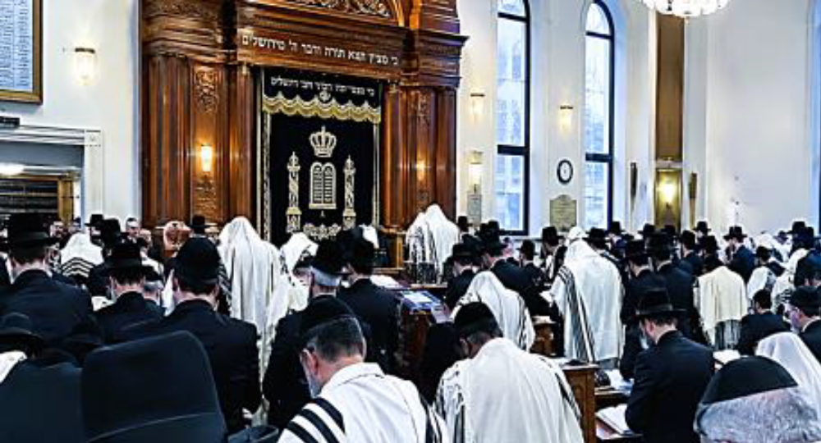

Since so many Jews had been estranged from their heritage, the rav did not anticipate a large crowd. But when Yom Kippur arrived, nearly 2,000 Jews streamed into the synagogue — men, woman and children — some not even knowing how to dress for such an event.
The rav stood before the crowd overcome with emotion. Looking out at the assembled congregation, he realized that many of them knew virtually nothing about Judaism. They had come only because they knew they were Jews and because something deep within them had drawn them there. To let that auspicious moment go without warming their Yiddishkeit was simply not an option.
He had to share something — something good — to send a flash of inspiration through their veins.
As Kol Nidrei was about to begin, the rav approached the podium. With deep emotions, he addressed the crowd. “My dear friends,” he said, “I would like to tell you a story about the holy Baal Shem Tov.
There was once a simple Jewish boy who lived far from any center of Jewish life. One Yom Kippur, he watched as people hurried to the shul dressed in white. Curious, he asked where they were going. They explained that Yom Kippur is the day when Hashem forgives His people. Jews gather to pray, repent, and ask for forgiveness.
The boy was deeply moved. “I want to pray too,” he thought. But there was one problem. He did not know how. The only thing he knew was the alef-beis.
Lifting his eyes Heavenward, he cried out, “Ribbono shel Olam, I do not know how to pray. All I know are the letters of the alef-beis. I will say the letters, and You Hashem, please arrange them into the prayer I wish I knew how to say.”
The Baal Shem Tov taught that the sincerity of that child’s words pierced the Heavens and opened gates that even great tzaddikim could not open.
The rav finished the story and turned back to the crowd. “My dear fellow Jews,” he said, “a child armed with nothing but the alef-beis could reach the Heavens. This is possible for us.”
Suddenly, voices from within the audience began to murmur: “But we don’t even know the alef-beis.”
The rav got word of their plea. Then, with tears in his eyes, he replied, “If that’s the case, I will say the alef-beis, and you repeat after me.”
The synagogue fell silent. “Alef!”
Two thousand voices answered, “Alef!”
“Beis!”
“Beis!”
One letter after another echoed through the sanctuary: Gimmel. Daled. Hei. Vav. The letters continued until they reached the final letter.
“Tav!”
And then it happened. The entire congregation burst into tears. Men, women, and children who knew virtually nothing about Judaism wept uncontrollably. They knew no prayers. They knew no Torah. Yet they knew one thing: they were Jews, and they had a Father in Heaven.
The yearning that had been buried beneath decades of oppression suddenly erupted from the depths of their souls. Who knows how high those expressions went.
Even years later, when many of those people went on in life, the rav would still speak about that unforgettable Yom Kippur.
Then he would turn to his audience and ask: “What about us? We know the alef-beis. We know how to daven. We were raised on Torah and tefillah. We have siddurim, yeshivos, rabbeim, and countless opportunities to draw close to Hashem. If those Jews cried because they longed to pray but did not know how, how should our prayers look?
“With what feeling do we stand before Hashem? How much must we appreciate the privilege of being able to pour out our hearts before the King of Kings?
“The Jewish soul naturally longs to connect with its Creator. The question is whether we allow that longing to find expression every time we open a siddur and begin to daven.”

Reprinted the Yom Kippur 5787 email of Zichru Toras Moshe.
A Chasid’s Skeptical
Question on Yom Kippur
From the Desk of Yerachmiel Tilles
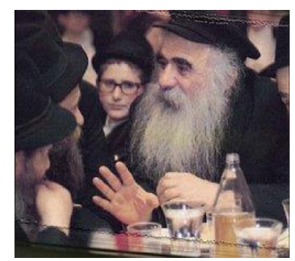

Rabbi Mendel Futerfass was a chasid of the Lubavitcher Rebbe, and the Rebbe said that everyone must be prepared to sacrifice their lives to ensure that as many Jews as possible get a genuine Torah education, even in [or especially in] the G-dless U.S.S.R, where Reb Mendel was born and lived.
Eventually, Reb Mendel was arrested, charged with the subversive activity of teaching Judaism and put in jail shortly after Rosh Hashanah 5708 (1947) until his trial. It was pretty clear that he would be found guilty and spend the rest of his life in Siberia, which in most cases wasn't much time at all.
A few days had gone by in his damp prison cell together with dozens of violent criminals, when he realized with dread that he would have to be there for all of Yom Kippur; The day of Forgiveness! On one hand he was sad to spend the holiest day of the year in this hell of a prison. But on the other hand, he was alive! And Jewish! And…a chasid of the Lubavitcher Rebbe! And that means, he said to himself, he must rise above the situation! That is what being a chasid is about.
That Yom Kippur night he decided he would consider his bed (which was a long plank of wood attached to the wall) to be a little Synagogue, and do his best to blank out the presence of the scary violent criminals and anti-Semitic Russian guards while he prayed. So, he sat on the sole seat in his shul (i.e. his bed) and said as many of the prayers of Yom Kipper as he remembered by heart. But it wasn't so easy. The prayers of Yom Kippur are only said once a year and there are a lot of them. He succeeded somehow in saying the evening and morning prayers by heart.
But when he reached the lengthy complex poems of Musaf [a second “Additional” morning prayer], he only remembered a small fraction, and that with difficulty. One prayer, however, stood out in his mind: a poem of the twenty-two lines, and each line begins with the words “Everyone believes…” (“Kol Ma'aminim”), and the third word on each line is in aleph-beit sequence: So, in the stillness of the night, while everyone else was asleep, he sat swaying gently back and forth on his bed praying quietly to the Creator: [beginnings of selected sample verses]
And all believe that HE is and there is none other… And all believe that HE knows our deepest feelings… And all believe that HE remembers the Covenant… And all believe that HE is good to all… And all believe that HE is a righteous judge…etc.
Suddenly the thought entered his mind "Oy, what am I saying here? 'Everyone believes? Everyone believes!' What about the evil communist regime? And what of the Jews of the atheist bloodthirsty Yevsektsia ('Jewish division' of the communist party), who are so fiercely dedicated to wipe out any mention of G-d and His people? Reb Mendel put this new question aside and finished his prayers.
Two weeks later he was transferred to a concentration camp and squeezed into a hall, where about sixty beds were crammed in tiers on the surrounding walls. All the hardened criminals snatched the best places, while he was pushed into a corner. He tried his best to be inconspicuous. It was Shabbat night, so he decided to wait until all the other prisoners were sound asleep. Finally, he was able to close his eyes and immerse myself in the Shabbat prayers.
Suddenly he felt that someone was staring at him. He looked up. It was Ivan, a huge mountain of a man with a scarred ugly face featuring a thick Uzbek mustache. Everyone knew him and was afraid of him. He was a known murderer. Now it seems that he had set his sights on poor Reb Mendel. Ivan jumped silently from his bed, crouching like a huge cat and quietly approached the Rabbi.
When he reached Reb Mendel he bent down, put his face into his and whispered forcefully and slowly, "You're Jewish, right?"
Reb Mendel never hid his Judaism; better to die a Jew than to live a lie. He looked him in the eye and answered firmly, "Yes!" "
And you are praying now, aren't you?"
Reb Mendel nodded. The murderer pointed to his own chest and whispered clearly, "So am I."
Reb Mendel was stunned.
"And I'll tell you something else" Ivan continued, "I even fasted this Yom Kippur!. He paused for what seemed an eternity and continued. "
A few days ago, I heard one of the Jewish prisoners say 'Tomorrow is Yom Kippur' and I don't know why, but I did it; I decided I was going to fast! The next day I told the guards I was sick and they put me in the 'hospital' (which was no more than an empty room with a wooden bed in it) and locked the door. I just sat there. After a while, however, I felt really uneasy. Then I remembered that my grandfather took me to services and he used to pray and cry to G-d with all the other Jews. Then suddenly I remembered a prayer! "It was something my grandmother used to say to me every morning when she woke me up. I remember.
"Modeh Ani L'fa'ne'chaw Melech Chai v'Ka'yam" ('I offer thanks before You, living and eternal King [for You have mercifully restored my soul within me; Your trustworthiness is great.')
"I don't even know what it means. Actually, I don't know a word of Hebrew, for even my father received a communist education, and I did not see a trace of Judaism in my father's house.
So, I sat in that room the entire day. That's right, I sat from the morning until when it became dark , and said over and over again: 'Modeh Ani L'fanechaw Melech Chai v'Kayam. Modeh Ani L'fanechaw Melech Chai v'Kayam.' "
He paused for another minute in deep thought, then snapped out of it. He pointed his finger at Reb Mendel and whispered menacingly, 'Now don't you tell anyone what I just told you, understand?! I said-nothing." After this conclusion he turned and slipped silently back to his place.
Reb Mendel sat in the silence staring at Ivan, who simply climbed into his bed, turned his face to the wall and was snoring instantly.
That’s when the thought entered his mind. 'Aha! This is an answer from Heaven to the question I had on Yom Kippur. If even that murderer believes, that is a sign that "Kol Maaminim' – Everyone believes!
[Source: Compiled and freely adapted by Yerachmiel Tilles from a weekly email a few years ago by Rabbi Tuvia Bolton, and from "Days of Awe, Days of Joy", the translation by Rabbi Chaim Miller of the original Hebrew edition by Rabbi Eli Friedman; (Kehot).]
Biographical note: [photo credit: chabadpedia.com] “Reb Mendel in Action” Rabbi Menachem-Mendel (“Reb Mendel”) Futerfas (1906 – 4 Tammuz 1995), was a near legendary Lubavitcher chasid, even for those who knew him personally. In 1947 he was arrested for administrating networks of underground yeshivas and Jewish schools, and for facilitating the repatriation of thousands of Soviet Jews to Poland after WWII. For three months he was interrogated, tortured and threatened with death, but he would not reveal anything about his co-conspirators or the underground religious schools. In the end, he was sentenced to 8 years in Soviet prisons and labor camps, which he went through without compromising any religious observances, despite the cruel pressure to do so. After another six years in Siberian exile, he was allowed to emigrate to England, thanks to an appeal for family repatriation made by prime minister Harold Wilson during his summit meeting in Moscow with Chairman Nikita Khrushchev. In 1973 settled in Kfar Chabad, Israel, for the rest of his life.

Reprinted from the Yom Kippur 5787 email of KabbalaOnline.org, a project of Ascent of Safed in Israel.

The Chofetz Chaim and
the Lumber Merchant
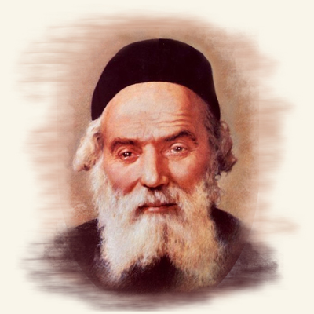

A lumber merchant would travel to Radin every year for Rosh Hashanah and Yom Kippur, in order to daven with the Chofetz Chaim. One year, after Rosh Hashanah, the merchant went to discuss with the Chofetz Chaim a serious legal dispute in which he was involved with several non-Jewish people.
The court case was scheduled for after Yom Kippur. When the Chofetz Chaim heard the merchant’s dilemma, he ordered him to return home immediately so that he should be around in case legal issues came up that he needed to be available for.
The merchant was shocked. How could he leave his Rebbi, the Chofetz Chaim, just before Yom Kippur? But the Chofetz Chaim’s instructions were clear, and the merchant knew to follow his Rebbi’s words to the letter.
The merchant returned home immediately. The very night that he got home, a severe storm swept through the towns and villages. Strong winds, rain, thunder, and lightning pounded on the villager’s homes.
In the middle of the storm, a group of Polish men who were on their way to the nearby forest, frantically pounded on the lumber merchant’s door. The storm caught them by surprise and they were looking for shelter at the nearest house they could find.
The lumber merchant welcomed them warmly into his home and supplied them with everything they needed. As it turned out, one of his guests was none other than the judge who would be ruling in the merchant’s legal dispute! The judge was very grateful to the Jew who had helped him when he really needed it. On the day
of his trial, the judge ruled in favor of the lumber merchant!

Reprinted from the 5787 Yom Kippur email of Rabbi Yehuda Winzelberg’s Torah U’Tefilah.

Reunion of the Heart:
A Yom Kippur Miracle
By Rabbi Aharon Margalit

How a heartbreaking vow turned into a holy reunion that changed two lives forever

Many years ago, during one of my trips to the United States, the man seated next to me caught my attention. He was Israeli, and I noticed his meal had a label: “Moshe Hershkowitz.” But although he had a clearly Jewish name, his food was obviously not kosher.
My curiosity got the better of me. I turned to him politely and said, “Excuse me, I don’t mean to offend, but can I ask you something?”
“Sure,” he replied.
“Did you know there’s a kosher meal option on this flight?” I asked gently.
He looked at me and said, “I don’t eat kosher,” his voice full of tension and pain.
Then he added, “Do you want to know why I don’t eat kosher?” From the way he spoke, I could tell this wasn’t a casual choice. It was a deep, painful struggle.
I nodded, and he began talking, more to himself than to me.
“It was because of my son. That’s what broke me. Somehow I survived. In the ghetto, on the train, in the concentration camp, I kept going. My wife was already gone. My other children too. Only he was left. I promised myself we would make it through.”
He paused, his eyes distant, as if lost in another time.
“One day, the Nazis called all the prisoners for roll call. But instead of letting us go afterward, they told us to turn around. Behind us, gallows. Dozens of them. People panicked and ran. In the chaos, I lost my son… and I never found him. Weeks later, someone told me he had been murdered.”
He wiped away his tears, now burning with grief and anger.
“Hashem took all my children from me! Every one of them! So, I told Him if I can’t be a father, then He can’t be a Father to me. Don’t talk to me about mitzvot. I don’t want to hear!”
I sat there stunned, overwhelmed by his pain. I didn’t know what to say. I mumbled something and turned away. We didn’t speak again during the flight, and when we landed in New York, we went our separate ways.
I never imagined we’d meet again.
Four years passed. My father became seriously ill, and my brother and I took turns staying with him every day, including Shabbat and the Jewish holidays.
That Yom Kippur, it was my turn. My father was living in a senior home in Jerusalem, and I helped him get to the small synagogue inside for the day’s prayers.
Right before Yizkor, the memorial prayer, there was a short break. I stepped outside to get some fresh air and there, sitting at the bus stop across from the building, was a man smoking a cigarette.

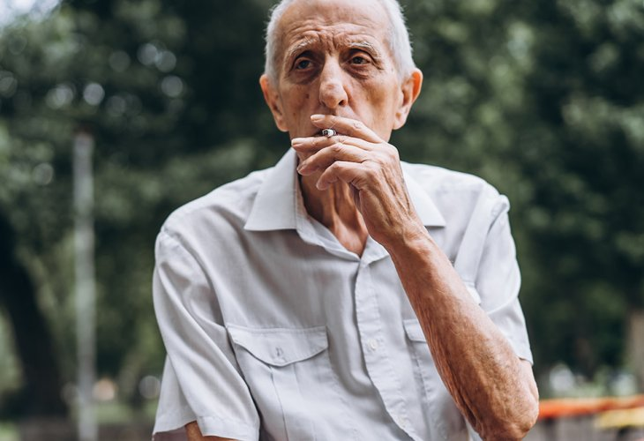

On Yom Kippur.
I looked more closely and suddenly realized who it was. Moshe Hershkowitz.
In that moment, I felt clearly that Hashem had brought us back together for a reason. I had been given another chance to reach out. I walked slowly toward him.
“Mr. Hershkowitz, here we are again. I don’t know if you remember, but a few years ago, we sat next to each other on a plane. It’s amazing how life brings people back together.”
He looked at me but said nothing.
I gently continued, “You probably know that today is Yom Kippur. In the synagogue right here, we’re about to say Yizkor, memorial prayer. Why don’t you come in and say a prayer for your son, who died al kiddush Hashem, for the sanctification of God’s name? You can honor his memory and pray for his soul.”
His eyes filled with tears. He didn’t argue. I offered my arm, and he slowly stood. Together, we walked into the shul.
When the Yizkor prayer began, I led him to the chazzan (cantor) and asked that a special prayer be said for a young man who had died in the Holocaust. Mr. Hershkowitz leaned against the platform and took a deep breath.
“Yonatan Uziel ben Yechezkel Shraga,” he said softly, clearly.
Suddenly, a man standing nearby turned pale. Sweat broke out on his forehead. He trembled all over. Then he looked at Mr. Hershkowitz and cried out in a choked voice, “Father! Father!” and fainted on the spot.
Baruch Hashem, the story had a beautiful ending. Moshe Hershkowitz was reunited with his son and eventually returned to a life of connection with Hashem. He was blessed with happiness and nachat, true joy from his son and grandchildren.
For me, this moment taught a powerful lesson about humility and healing.
Moshe had lived for years filled with anger toward Hashem, convinced he was right. And yet, when someone gently suggested he take one small step back just to say one prayer for his son, he agreed.
Sometimes people live trapped in their pain or their beliefs, unable to consider another way. Even if they’re unhappy, even if it’s hurting them, they still say, “This is who I am.”
But real change doesn’t always need something dramatic. Sometimes all it takes is a small moment of openness. A quiet “I’m sorry.” A warm smile. A simple prayer, even if you’re still hurting.
The Torah teaches us that if we take one step toward Hashem, He will take many steps toward us.
May we all be blessed to feel His kindness, healing, and love in our lives.

Reprinted from the Yom Kippur website of Hidabroot.com.

